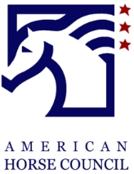

2022 Economic Impact Study – Pledge Form

Yes! I/We would like to support the American Horse Council’s National Economic Impact Study.
___ Platinum $25,000 ___ Benefactor $2,500

___ Gold $15,000 ___ Patron $1,000

___ Silver $10,000 ___ Supporter $500 - $100
(Minimum contribution of $100)
___ Bronze $5,000

Individual or Company Name: ________________________________________
Contact Name & Email: _____________________________________________
Address: _________________________________________________________
Phone: __________________________________________________________

___ I have enclosed a check payable to the AHC Foundation
___ Please invoice me for the full amount or invoice me in quarterly payments.
___ I authorize AHC to charge my credit card

CC#: _________________________________ Exp date: _______________
Name on card: __________________________ Amount: ________________

Please return pledge form to: American Hors Council, 1616 H St, Suite 700 Washington DC 20006

